Pre-Registering for Classes
Registering for Classes Online

Students with < 30 earned credit hours are to contact their academic advisor to pre-register
Students with ≥ 30 earned credit hours can pre-register online through their Student Portal. BE PAREPARED:
- Clear outstanding administrative Holds: Pre-Registration is only for students who do not have 'holds' on their account
- Address any Academic Alerts: outstanding Academic Alerts. Alerts will prevent you from pre-registering
- Remove Pop-up Blockers
- Review your Degree Audit, which is available on your Student Portal

ADVISING:
- Schedule an appointment with your academic advisor prior to pre-registering online.
  - Pre-registration times are determined by EARNED credit hours:
Sophomore = 30.0 credit hours or more; freshmen = 29.0 or less
- Meet with your advisor to review your degree audit and discuss your course selection.

If you need your username and/or password reset, go to Manor College’s homepage, www.Manor.edu,
“Current Students” [top right menu] and click on “Password Resets.”

Step 2: Select the correct term you wish to pre-register for from the drop down menu on the login page.
  - Term Key (xx represents the year)
Fall = FA-xx
Spring= Sp-xx
Summer = Su1-xx
Su2-xx

Step 3: Click on Registration 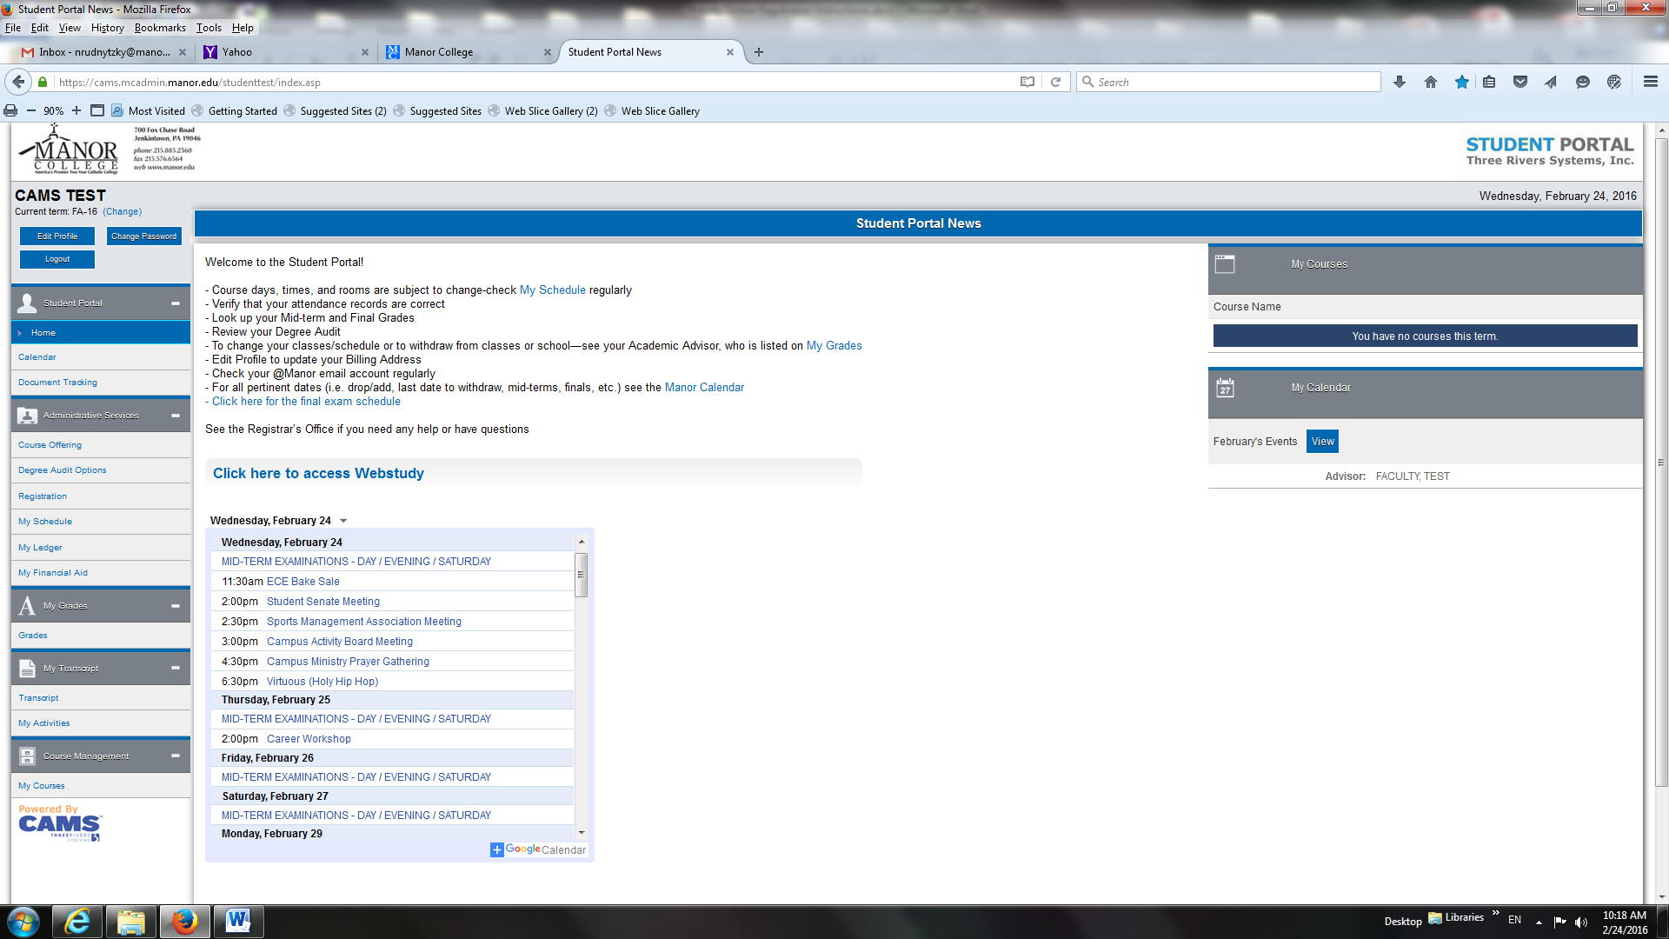
Step 3:
Click on Registration

Step 4: Search for the courses you want to register for. There are two ways:
  - Click on “Show Filter” and search by department, course number, days of week, etc.
OR
  - Scroll through each individual page to select courses

Using the Filter:
    - Click on “ ”
    - Enter the department prefix and or the course number, or any other data such as days, times, etc.
    - Click Apply filter to see the courses for which you searched
NOTE: Only courses that have all pre-requisites satisfied and apply to your degree audit will be available for you to register by having a credit box (i.e., ) to check on the left side.
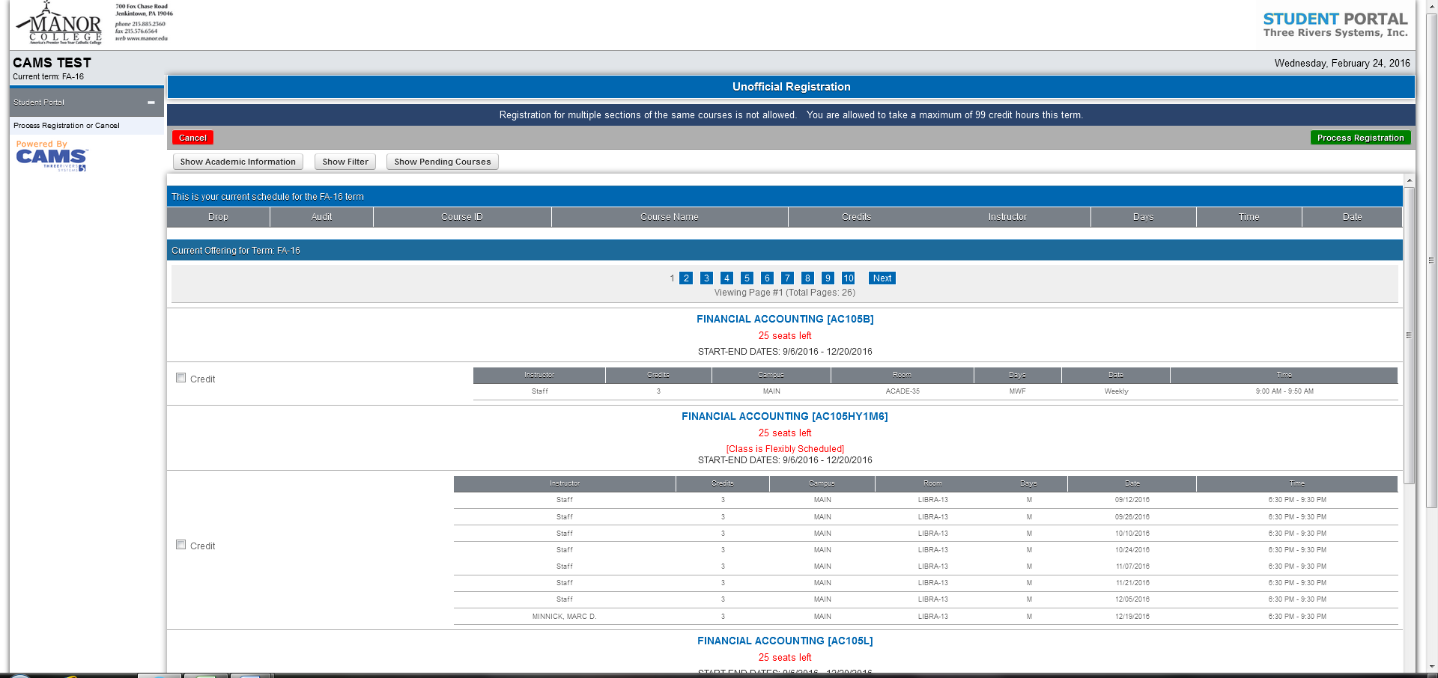
Step 4:
click
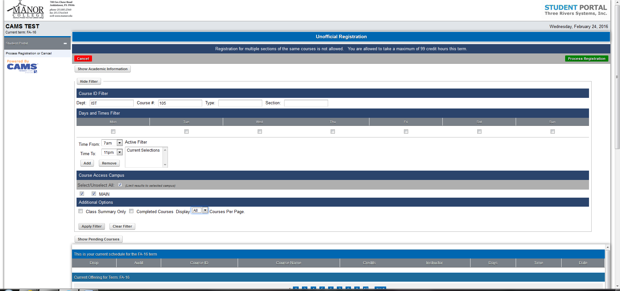
After entering the course info; click Apply Filter here.
Step 4:
Using the Filter.
Enter the desired course Dept. prefix and number (i.e., IST 105)

Step 5: To select your courses, check the ‘Credit’ box, which is lined up with the grayed out course information.

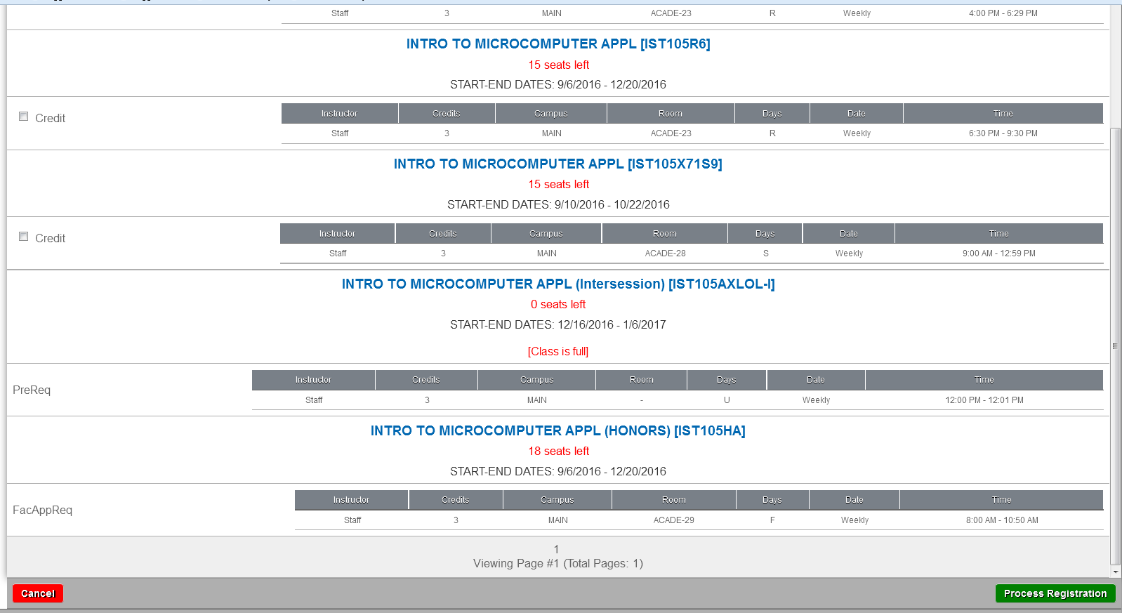
Note the days and times of the classes are here.

Classes without check boxes are unavailable for registration for the following reasons:

  - “PreReq” - Prerequisite has not been satisfied
  - “FacAppReq” - Faculty or Chair approval is needed for course
  - “DegAudit” – course is not part of your Major’s curriculum

If you try to register for a class that is held at the same another class is scheduled you will receive the following pop-up:
Click “OK” and chose another section (never check the Prevent box if it appears – it may cause a crash.)

Step 6: Click on in the top right corner of the screen.
  - You may select multiple courses at a time OR
  - You may select each course individually and process registration between each course selection.
12-18 credit hours is a full-time load.

Click “OK” on the confirmation box:

An unofficial schedule will appear on your screen.

You can print it up by clicking the icon on the top right corner.

You can also click on the left side for a weekly schedule (with a print option on the top right.)

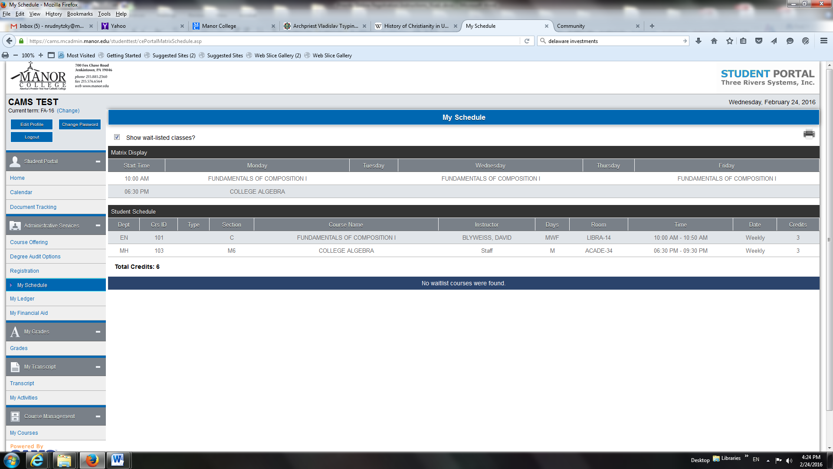

Step 6b: Check you unofficial bill by clicking (note: this may not have pending financial aid included.)
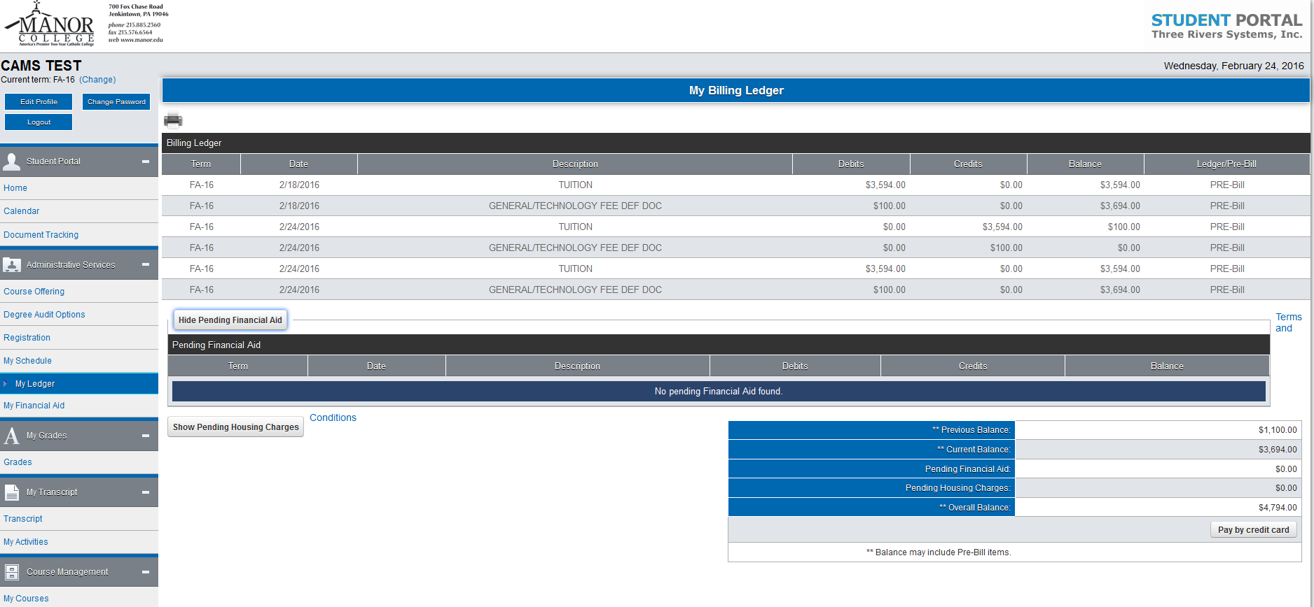

Step 7: Check your schedule periodically as it is subject to change.

Step 8: Email your advisor to let him or her know you are registered so it can be checked.

Step 9: Visit the Financial Aid Office

Adding & Dropping Classes Online

Adding & Dropping Classes Online

After you pre-register for classes, you may make changes through the Portal up until the term begins. Once the term begins, the Portal will be closed and changes must be done by your advisor or by the registrar on drop/add forms, which are available in the Registrar’s Office. Advisor signature is required. You can also email your advisor, using your Manor account. If approved, your advisor will notify the registrar’s office for processing. Students have one week to make schedule changes.

To make changes online, click in Registration as shown in Step 3.

To Add: Follow the same process as when registering by clicking the ‘credit’ box and the ‘process registration”.

To Drop: At the top of the screen in your schedule, click the box under ‘drop’ for a course you wish to drop and click ‘process registration’.

To Add and Drop at the Same Time: Check the ‘drop’ box for the course(s) you wish to drop and find the course(s) you wish to add and check the ‘drop’ and ‘credit’ boxes, and then click ‘process registration’.

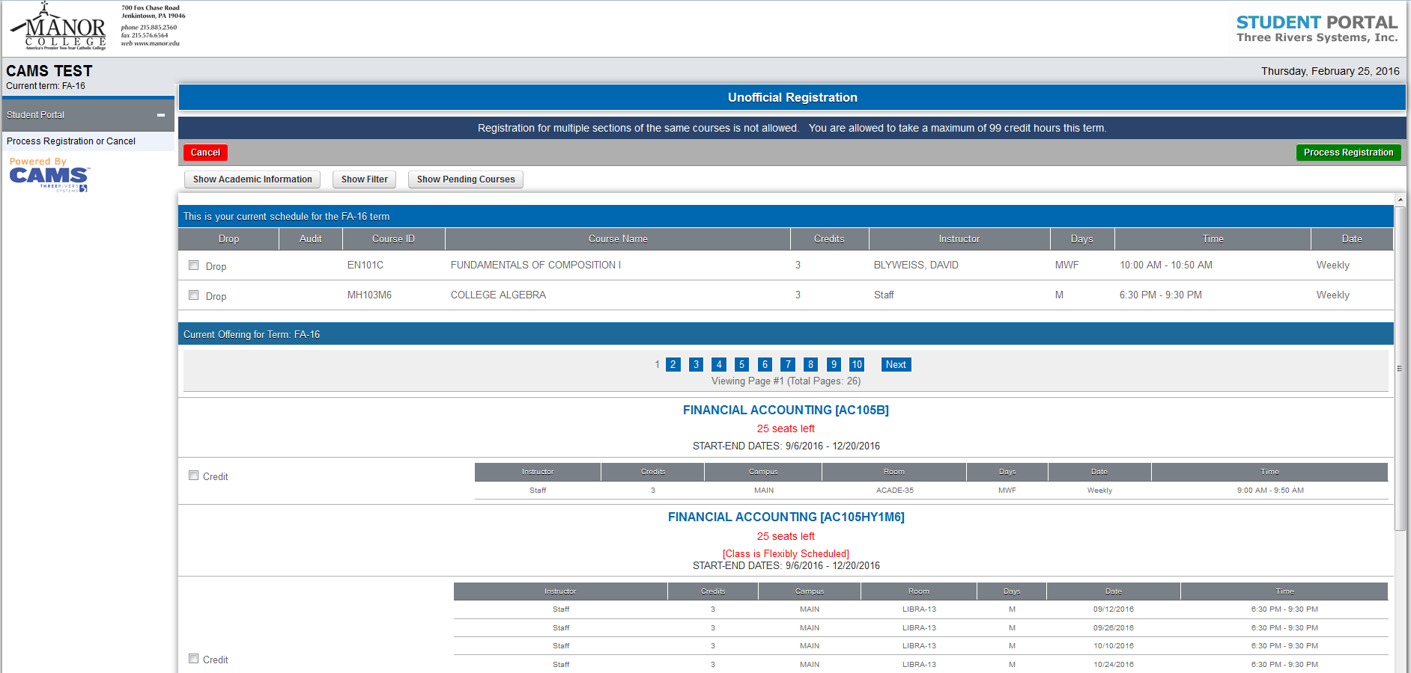

Enjoy the freedoms and responsibilities that come with taking ownership of your registration for classes.

If you have problems registering please visit the Registrar’s Office on the ground floor of the Basileiad Manor (Room 3 – downstairs, 4th door on the right after you pass the main counter.) We have computers here for you to use.

